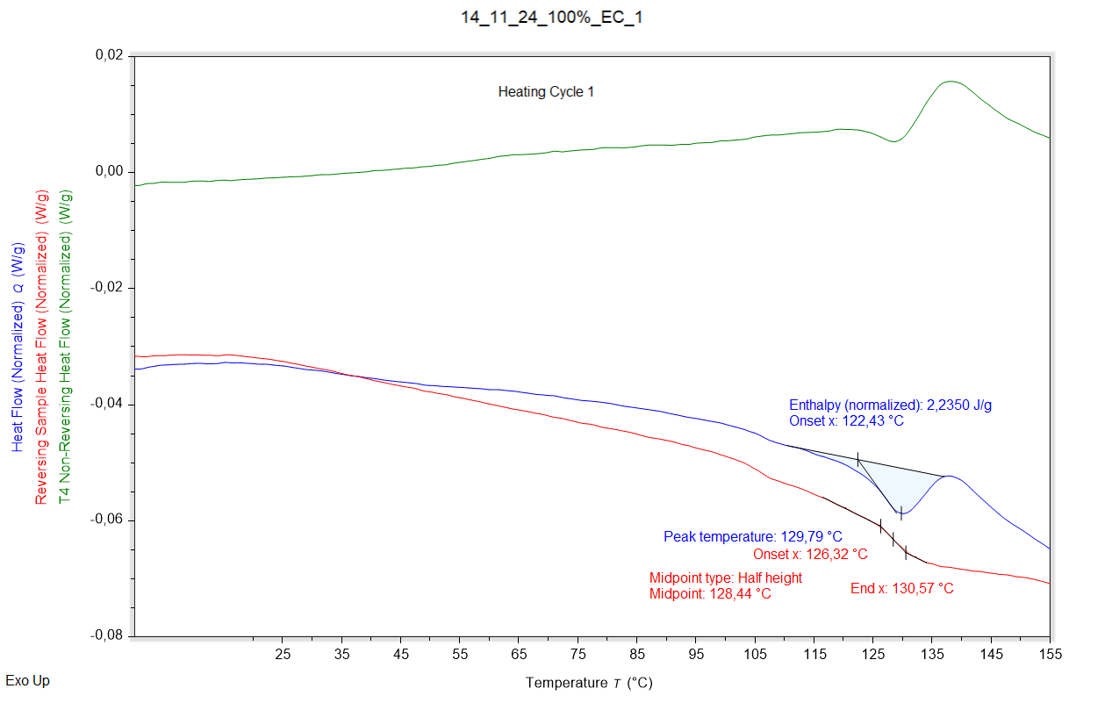

|  |  |  |  |
| --- | --- | --- | --- |
| Enthalpy recovery | Enthalpy recovery onset (°C) | Enthalpy recovery peak (°C) | Enthalpy recovery enthalpy (J/g) |
|  | 122,428 °C | 129,795 °C | 2,2350 J/g |

|  |  |  |  |
| --- | --- | --- | --- |
| Glass transition | Glass transition onset (°C) | Glass transition midpoint (°C) | Glass transition endpoint (°C) |
|  | 126,317 °C | 128,436 °C | 130,567 °C |

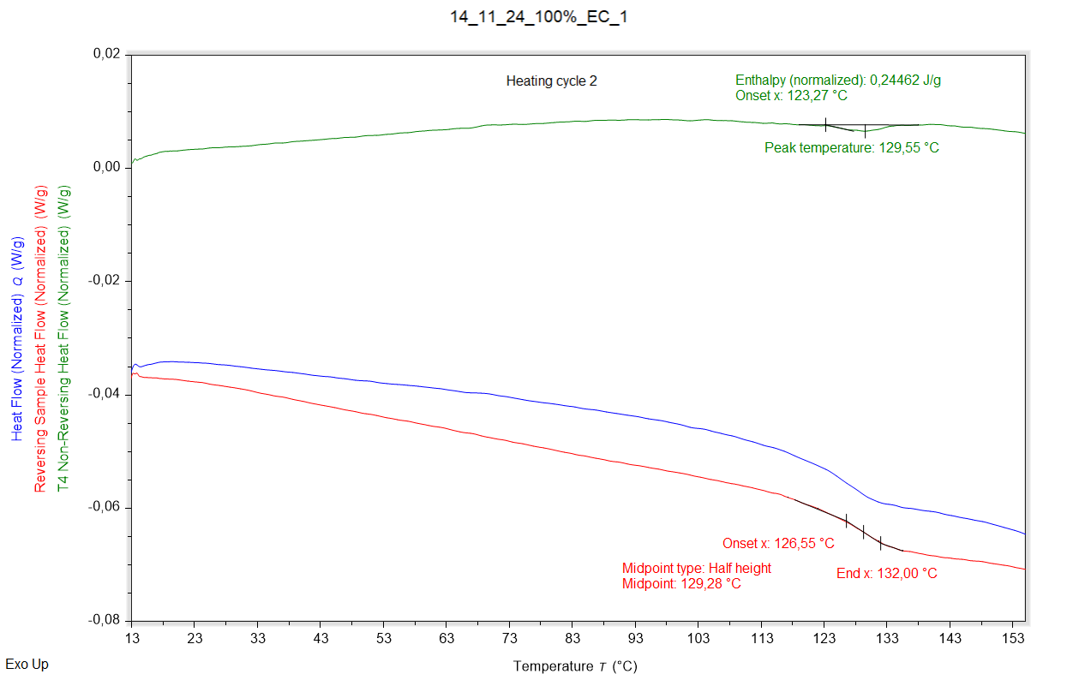

|  |  |  |  |
| --- | --- | --- | --- |
| Enthalpy recovery | Enthalpy recovery onset (°C) | Enthalpy recovery peak (°C) | Enthalpy recovery enthalpy (J/g) |
|  | 123,268 °C | 129,548 °C | 0,24462 J/g |

|  |  |  |  |
| --- | --- | --- | --- |
| Glass transition | Glass transition onset (°C) | Glass transition midpoint (°C) | Glass transition endpoint (°C) |
|  | 126,554 °C | 129,281 °C | 131,996 °C |